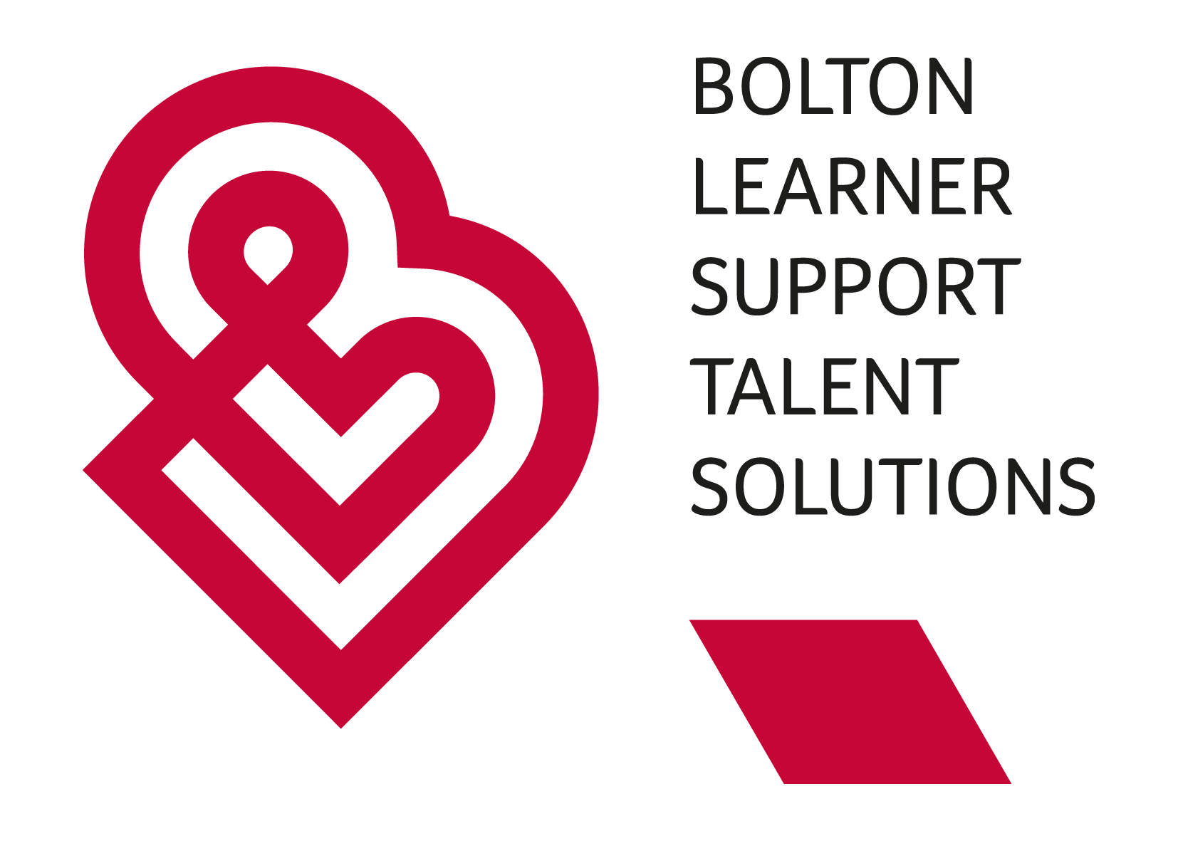

### Person Specification

You will need demonstrate the extent that you have the necessary requirements for this role. Please use examples in your application how you match the criteria in the person specification and your experience of the responsibilities outlined for the role.

|  |  |  |
| --- | --- | --- |
|  | **Essential** | Desirable |
| Education, qualifications and training | GCSE Maths and English minimum grade 4 or equivalent  Level 2 or 3 QCF award in Health & Social Care – Children or Adults, or willingness to commence award within the timescales set by BLSTS. | Safeguarding training  Makaton  Emergency First Aid. |
| Experience and skills | Ability to undertake the full range of tasks, in a well-planned way that respects & values the students as individuals.  Flexibility to respond to the needs of the students.  Good communication and interpersonal skills, both verbal and written.  Good organisational and time management skills.  I.T. Skills  Emails / Word/ Excel / College systems  Knowledge of using Zoom / Teams.  Ability and resilience to work with behaviour, which may challenge, in a caring and consistent manner, including the maintenance of appropriate boundaries for behaviour.  Ability to work individually on shift using your own initiative and as part of a team, maintaining & encouraging, open and honest communication. | Multi-disciplinary approach to meeting clinical, physical and emotional needs.  To assist with risk assessments the students require. |
| Knowledge and understanding | Knowledge and understanding of Safeguarding and the procedures  Knowledge of the issues affecting disabled people. | Knowledge of Ofsted and CQC and the Inspection process.  Knowledge of the Social Model of Disability. |
| Other | Commitment to continuing personal and professional development.  An enthusiastic, reliable person with a level of maturity and skills and interests which can be utilised to engage with students.  A flexible working approach to mee the needs of the individual learners and the service  The resilience to adapt to change |  |

Applications are welcome from all regardless of age, disability, marriage or civil partnership, pregnancy or maternity, religion or belief, race, sex, sexual orientation, trans status or socio-economic background. We are committed to making reasonable adjustments for disabled people. We positively encourage applications from those with lived experience.

# Additional information

The work at BLSTS for those working directly with the service users can on occasion be physically demanding and employees must be able to undertake in full the requirements of the job and requisite training.

For the safety of staff and the learners, specific training will be provided to assist employees to carry out their role.  Employees will be required to fully participate in all training.

Having a disabling condition does not preclude you from working for BLSTS.  However, you should make BLSTS aware of any adaptations required to enable you to undertake the work.

We are committed to safeguarding and promoting the welfare of children, young people and vulnerable adults and expect all our staff and volunteers to share that commitment.

BLSTS is committed to equality and diversity, but is under represented in the work force by men, men and women from ethnic groups and people with disabilities.  The BLSTS therefore welcomes applicants regardless of their racial, ethnic or national origin, religion or beliefs, disability, sexuality, age or responsibilities for dependents.