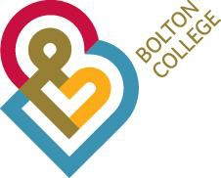

Higher Level 4/5 Admissions Policy and Procedures
2023-24

Content Page
Introduction 3
Applications 3
Application Process – New Learners 4
Application Process – Internal Progression 5
Enrolment and Payment 5

Appendices
- Entry requirements not met Email 6
- Conditional Offer Email 7
- Rejection Email 9
- Appeals Form 10
- Staff Procedures for Appeals 12
- Extract from the Advanced Learning Loan Self-declaration 13

- Introduction

  - Bolton College recognises that applying for a Higher Level 4/5 course can be daunting and therefore, this policy has been developed to provide clear guidance on the College’s Higher Level 4/5 admission process for applicants and staff.

  - This Policy relates to all Higher Level 4 Courses delivered by the College.

  - Bolton College is committed to providing a high-quality service to all our applicants that is welcoming, efficient and fair.

  - Applicants are considered on their individual merits including their qualifications, advanced prior learning, references and experiences. Our Programme Areas may also use an interview and/or assessment as part of the decision-making process.

  - Bolton College is committed to providing equality, diversity and inclusion and we will not treat applicants unfairly in relation to any protected characteristics as outlined in the College’s Equality and Diversity document. https://issuu.com/boltoncollege1/docs/e_d_report_2022_v4
and
https://www.boltoncollege.ac.uk/about-us/keeping-you-safe/equality-and-diversity/

  - Bolton College recognises and values the cultural, social and ethnic diversity reflected in our students and staff. As a result, we treat all with respect and dignity, and seek to create a positive learning and working environment.

  - Bolton College welcomes applications from motivated people who can demonstrate a passion and commitment to their chosen course of study, as well as potential to achieve academically.

  - We offer high quality information, advice and guidance to all applicants and we will work with individuals to provide appropriate support and ensure our courses are accessible.

  - Course information can be accessed via: College web; Student Services; Course Leaders.

Applications

  - In line with Bolton College ethos:
    - We will consider all applicants received at least 5 working days before the course starts
    - We also adhere to the Office for Students (OfS) relevant conditions, and the Office of Independent Adjudicators (OIA) guidance for appeals against rejection of application.

  - In exceptional circumstances applications may be considered once the course has started.

  - Bolton College is currently unable to accept applications from non-EU (overseas) residents.

  - Examples of our most current College Regulations, Learner Agreement and Information Sheets on ‘Covering the Cost of Your Course’, ‘Advanced Learning Loan’ and ‘Financial Support for Learners 19+’ can be viewed by request to our Helpline via info@boltoncc.ac.uk

Application Process – New Learners

- Applicants will be expected to apply online and create a Bolton College Learner Hub Account. Support to do this is available from our Admissions Team via our livechat service (available on all our website pages).

- All applications received are recorded within EBS by the Admissions Team.

- Where an application is made with insufficient prior qualification information provided or, if the information provided indicates that the relevant prior qualifications have not been gained, the Admissions Team may inform the individual that their application cannot be progressed further at that time (Appendix 1)

- All applicants will be invited by text to book a telephone interview via text by the Admission Team, within 2 working days of an application being received by the College (at peak times this response time may increase). Note: The college reserves the right to conduct interviews/admissions online should this be necessary in event of any future Covid Lockdown or other relevant reason.

- The applicant will receive immediate verbal feedback at the end of the interview (unless references or further information is required before a final decision can be made).

- Email confirmation of the interview outcome will be sent by the Admissions Team (where an offer has been made in Term 3, instructions on how to complete enrolment will be included. See Appendix 2) within 10 working days of the decision being made. N.B. Tutor needs to put offer on to EBS promptly.

- Where an offer is made to an applicant who has indicated additional needs, a member of the Learner Support Team may contact the applicant directly to discuss their specific needs prior to or after an offer has been made.

- Where an offer is not made, the applicant will receive written information on where to obtain further information, advice and guidance (see Appendix 3).

- Bolton College has an Appeals Process for unsuccessful applicants and an appeal form will be included in the email sent to unsuccessful candidates by the Admissions Team (see Appendix 4).

Application Process – Internal Progression

  - Learners wishing to progress within the same curriculum area

- Bolton College learners wishing to progress to a Higher Level 4/5 course within their current curriculum area will be interviewed by a Tutor as part of their existing course. This will usually take place in Term 3 and the interview outcome will be recorded within EBS by the Tutor.

- The learner will receive emailed confirmation from the Admissions Team of the interview outcome and, either details of how to complete enrolment or how to access information, advice and guidance on alternative courses (see Appendix 2 and Appendix 3).

- Where an offer is made to a learner who has indicated additional needs, a member of the Learner Support Team may contact the applicant directly to discuss their specific needs prior to or after an offer has been made.

- Bolton College has an Appeals Process for unsuccessful applicants and an appeal form will be included in the email sent to unsuccessful candidates by the Admissions Team (see Appendix 4).

Learners wishing to progress to a new curriculum area

a) Bolton College learners wishing to progress to a Higher Level 4/5 course in an area other than the one they are currently studying in will be treated as new learners and as such will follow the same admissions process detailed in Section 3.

Enrolment and Payment

- Enrolment will be online using the individuals Learner Hub Account. Help to complete enrolment is available via our livechat service or email to learner.hub@boltoncc.ac.uk

- A learner is responsible for their course fees until they are paid in full.

- Where an instalment plan is required, full payment must be made according to the instalment agreement put in place.

- If a learner wishes to use an Advance Learner Loan to fund their course they must apply for the Loan in a timely fashion and, at the time of enrolment, sign a self-declaration to confirm that they understand that they are personally liable for the full payment of the full course fee if the Loan is not applied for or, granted within 6 weeks of the first class attended (see Appendix 6).

- A learner is entitled to a 14 day “cooling off” period from the start date of the course. If they wish to withdraw from the course within the 14 days they are eligible to a full refund of fees paid. Our full refund policy can be found on our website:
https://www.boltoncollege.ac.uk/about-us/governance/key-policies/

Appendix 1: Prior Qualifications Email

Dear

Thank you for your application for a place on one of our Higher Level 4/5 courses.

Unfortunately, as your application form indicates that you do not meet the course entry requirements in relation to existing, or pending, qualifications we are unable to progress your application any further. Should you wish to update your application with missing existing, or pending, qualifications please contact our Admissions Team via admissions@boltoncc.ac.uk and provide your College ID number in your message – [insert ID]

At Bolton College we offer a wide range of courses that we feel may be more suited to your qualifications. If you would like to speak with one of our careers advisors regarding further advice then please call on 01204 482182 to make an appointment. Alternatively, you may also benefit from contacting the National Careers Service at https://nationalcareersservice.direct.gov.uk/ .

If you wish to appeal against the decision then please complete the attached form and return it to our HE Academic Quality Leader within 10 working days. We will review your appeal and reply to you within 10 working days of receiving it.

We wish you every success in your future education and career.

Attached: Appeals application

Appendix 2: Offer Email

Dear
[Insert first name]

Congratulations

We are delighted to confirm your offer of a place on our

course.
Course Name

Your next step is to complete your enrolment online and I have provided details of how to do this below. Once you have followed the process we will send you confirmation of your place

Please note: The health and safety of our learners and staff is very important to us and with the continued situation, related to the coronavirus outbreak, there may be a continued emphasis on study outside the classroom during the 2022/23 academic year. The proportion of these hours will depend on the individual qualification(s) being undertaken. You must do the work set during directed study or it will impact your progress on the course and therefore your achievement.

If you need to ask any questions about your course please do not hesitate to reply to this email.
You are entitled to a 14 day “cooling off” period from the start date of this course. If you wish to withdraw from the course within the 14 days you are eligible to a full refund of fees paid. Our full refund policy can be found on our website https://www.boltoncollege.ac.uk/about-us/governance/key-policies/

Instructions on how to complete your enrolment for 2022/2023

You will need this information to enrol:

  - Your national insurance number
  - If you pay for your course - your credit or debit card. If you wish to pay by instalments you will need your credit or debit card (to pay your first instalment) and your bank details to set up your monthly payments.
  - If your employer is paying for your course – a letter confirming this on letter headed paper (to be uploaded as ‘evidence’ of why you are not making a payment).
  - If you plan to use an Advanced Learner Loan to pay for your course - you do not need your Loan confirmation letter but you will be asked to fill in a declaration form as part of your enrolment.

You can access a really useful presentation on how to apply for the Loan online here: https://www.boltoncollege.ac.uk/about-us/student-support/financial-support/advanced-learner-loans/

When you are ready to enrol:

- Type this link into your web browser: https://applications.boltoncollege.ac.uk (please don’t use Explorer for this as it may not work)

- Log in to your Learner Hub Account using your username – We have a
Network User ID
‘forgotten password’ service if you don’t remember or don’t know your password. The password reset email will go to this account
Personal Email

- Once in your account, look for the section entitled ‘My Actions’ and click on the text ‘Start Enrolment for…….’ and work through the screens to complete your enrolment.
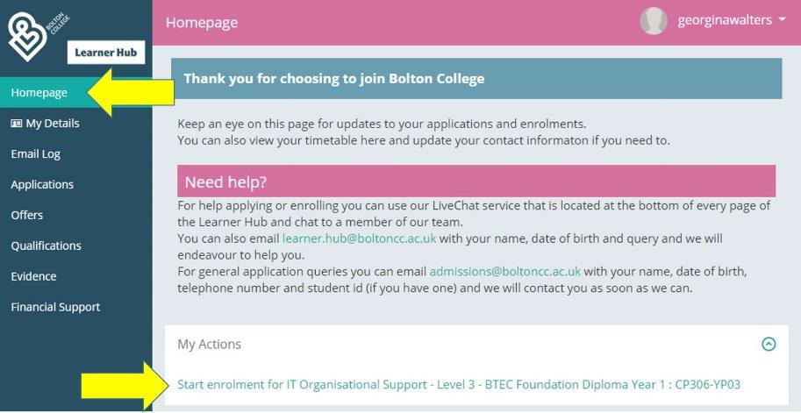

Need help re-enrolling?

If you experience any problems completing your enrolment, please contact a member of our Learner Data Team via our livechat service which is available from any of the screens in your Learner Hub account.

We endeavour to staff these services from 9am – 4pm, Monday to Friday.

Need to change your contact details?

If your Learner Hub account is showing the wrong contact details you can update your email address and phone number yourself.

If you need to change your home address please email your new details to ldteam@boltoncc.ac.uk Please include your full name and your College ID number -
Person
- in your message.
Code

Yours sincerely

Admissions Officer

Appendix 3: Rejection Email

Dear [Insert first name]

Thank you for your application for a place on our [Insert full title of course] at Bolton College. Unfortunately, we are unable to offer you a place due to [insert clear and transparent reasons].
If you wish to appeal against the decision then please complete the attached form and return it to our HE Academic Quality Leader within 10 working days. We will review your appeal and reply to you within 10 working days of receiving it.

At Bolton College we offer a wide range of courses that we feel may be more suited to your qualifications including many Level 3 courses. If you would like to speak with one of our Careers Advisors regarding further advice then please call on 01204 482182 to make an appointment.
Alternatively, you may also benefit from contacting the National Careers Service at https://nationalcareersservice.direct.gov.uk/ .

We wish you every success in your future education and career. Yours sincerely

Admissions Officer

Attached: Appeals application

Appendix 4

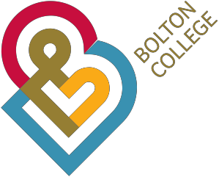

Appealing against a rejection decision for a Higher Level 4/5 course

If you are not satisfied with the reasons given for rejection of a place on your chosen course, then please complete the form and return within 10 working days of receiving the rejection letter. Please complete all sections of the appeals form and return to:
Bolton College
HE Academic Quality Leader Deane Road
Bolton BL3 5BG
Tel: 01024 482017
jill.hebden@boltoncc.ac.uk

Print Name:
Print Address:
Print Full title of course name applied for:
Please state what reasons were given for rejection in the letter of rejection:

Reasons for appeal. Please give reasons as to why you should not have been rejected from admittance to the course.
Please use more paper if you need to.

Please include any more information in support of your appeal. (For example, a letter from someone who is supporting you in your appeal).
Please use more paper if you need to.

Please PRINT and sign form:
Please state date:

Appendix 5

Staff Procedures for Appeals against rejection decision for Higher Level 4/5 course

  - Tutor informs and sends reasons of rejection to Admissions Team

  - Admissions Team sends letter of rejection to applicant and includes information on how the applicant can appeal and the timescale for appealing. Timescale must be within 10 working days of receiving letter

  - Applicant completes appeal against decision form and sends to HE Academic Quality Leader.

  - HE Academic Quality Leader or Assistant Principal of Curriculum and Quality investigate the appeal. The outcome and letter to applicant must be sent within 10 working days of receipt.

  - Letter of outcome of appeal is sent to applicant who has appealed. If appeal is unsuccessful the letter will include information on why the appeal has been unsuccessful.

  - If appeal is successful then the applicant will be invited to enrol on the course.

  - The Course Leader and tutors will give as much academic support to the student in order that they are not disadvantaged with their studies.

Appendix 6

Extract from the Advanced Learning Loan Self Declaration Form

Financial Statement
By enrolling on this course, you are agreeing to a legally binding agreement with the College and specifically acknowledge that you are: -

- Accepting liability for the payment to Bolton College of the full course fees and ancillary charges in any event, including if should you fail to make an application to the Student Loans Company or if your application to the Student Loans Company is not approved;
- Accepting liability to reimburse the College for any shortfall between the course fee and ancillary charges levied by the College and those course fees and ancillary charges which are paid on your behalf by the Student Loans Company;
- Accepting liability for the payment of any balance of course fees and ancillary charges should the Student Loans Company withdraw its loan offer to you or cease to fund your learning directly to the College for any reason whatsoever (including if you fail to complete the course).

If any of the above apply or the College fails to receive payment in full for any other reason, you acknowledge that you are liable for the College’s fees and any additional fees incurred in recovering such amounts from you. You specifically and irrevocably authorise the College to retain any monies it receives from the Student Loans Company in satisfaction of its course fees and ancillary charges. These provisions apply whether you complete the course or not.

If you have not already applied to the Student Loans Company and wish to do so you must do so immediately after your enrolment. The College has the facility to track applications and where no evidence of application is evident within four weeks of your enrolment, an invoice will be issued to you for payment in full.

Instalment plans are available for any fees you may be required to pay in the event that you are not funded by the Student Loans Company or you have a balance owing after deduction of funding paid to the College on your behalf by the Student Loans Company.

Please note that no refunds are available under any circumstances, and that the College will pursue through appropriate legal avenues any funds due from any learners which remain unpaid after the due date. This applies whether you complete the course or not.

