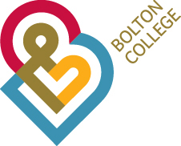

**Lecturer B : Beauty Therapy & Nail Services**

**7.4 hours per week (0.2 FTE)**

**£27,453 – £33,311 per annum (pro rata)**

We require an experienced and highly motivated Lecturer B in Beauty Therapy and Nail Services. You will support the Curriculum Leader by co-ordinating a small team of staff in the delivery of high quality and inclusive provision within the Beauty Therapy and Nail services departments. You will co-ordinate and deliver teaching and learning on Beauty Therapy and Nail Services programmes up to Level 4.

We are looking for a dynamic and innovative individual with a passion for achieving excellence through delivering a first class quality service at all times. For this position, you will need a degree or equivalent in a relevant subject specialism and a PGCE / Cert Ed. You will also have teaching and assessing experience on Beauty Therapy and Nail Services courses across a variety of levels, and experience of co-ordinating a team.

An application pack can be downloaded from our website by accessing (www.boltoncollege.ac.uk), by email request to: [personnel@boltoncc.ac.uk](mailto:personnel@boltoncc.ac.uk) or by telephoning 01204 482 106.

**Closing Date:** 18th July 2018

**Interview Date:** 23rd July 2018

**Job Ref:** 101-17