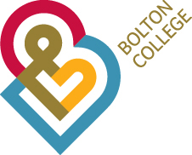

**Social Media Assistant**

**Admin / Support Scale £17,485 per annum**

37 Hours per week

If you know your boomerangs from your filters and your tweets from your boosted posts, then we want to hear from you. We are on the lookout for a creative individual with a passion for all things social media to join the Bolton College Marketing Team.

Your main responsibilities will be to focus on producing creative, engaging social media content using the appropriate platforms including, Facebook, Instagram, Twitter and more. You will develop content for all channels, taking into consideration varied target audiences. The ideal candidate will be the main point of contact for social media, covering a range of exciting events within College. You will also head up the internal social media ambassador programme.

If this sounds like the ideal position for you, please apply using the links below. If you wish to discuss this role further, please call the Marketing Team on 01204 482 141.

An application pack can be downloaded from our website by accessing (www.boltoncollege.ac.uk), by email request to: [personnel@boltoncc.ac.uk](mailto:personnel@boltoncc.ac.uk) or by telephoning 01204 482 106.

**Closing date: 24 August 2018**

**Interview date: 6 September 2-18**

**Ref No: 007-19**