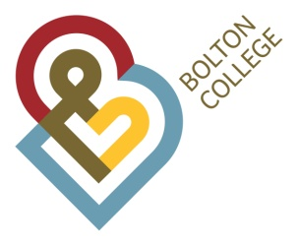

Person Specification

Post | Communication Support Worker |  | Dept | learner support
Grade | £17.52 - £21.91 per hour |  | Ref No | 197-22

Education / Training |  |  | Criteria Essential (E)  Desirable (D) | Measured By  Interview (I)  Application (AF)  Assessment Ctre (AC)  Presentation (P)
Stage 3 British Sign Language or equivalent  Level 3 qualification or equivalent  Level 2 qualification in English and Mathematics  Note taking qualification  Level 3 English qualification  CSW qualification |  |  | E  D  E  D  D  D | AF  AF  AF  AF  AF  AF
Relevant Experience

Experience of supporting D/deaf students in educational settings  Experience of maintaining records  Liaison with a variety of external agencies/ organisations. |  |  | E  E  D | AF/I  AF/I  AF/I
Relevant Knowledge/ Skills & Aptitudes |  |  | e / d | Measured By
A positive attitude towards D/deaf people and knowledge of the Deaf community.  Be able to adapt their signing skills in order to meet the needs of the D/deaf students.  Deaf awareness.  Good interpersonal skills  Knowledge of the language implications of the D/deaf. |  |  | E  E  E  D  D | AF/I  AF/I  AF/I  AF/I  AF/I
Special Requirements |  |  | E / D | Measured By
The successful post holder would be expected to have a flexible approach to their work.  The post holder would be required to demonstrate an ability to act with discretion and maintain confidentiality.  Must be willing to undertake appropriate training and development in order to meet the requirements of the college.  Commitment to the principles of valuing diversity and equal opportunities.  Bolton College is committed to safeguarding and promoting the welfare of young people and vulnerable adults and expects all staff and volunteers to share this commitment. |  |  | E  E  E  E  E | AF/I  AF/I  AF/I  AF/I  AF/I

