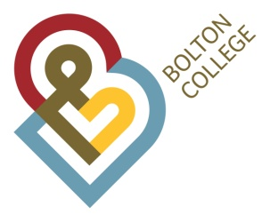 Deane Road, Bolton, BL3 5BG

Our Ref: vac : 158-23
Enquiries to: Victoria Sinclair
Tel No: 01204 482 106

As postmark

Dear Sir/Madam

Learning & Development Mentor (3 vacancies – 2.5FTE)
37 hours per week (Term time only 36+3 weeks per year)
Scale 5
£20,196.83 - £21,932.17 per annum (actual FTE salary)

Thank you for expressing an interest in the above role at Bolton College. I am pleased to enclose the application pack, which you recently requested. Please return the completed application form to Human Resources, Bolton College, Deane Road, Bolton BL3 5BG. The closing date for the post is 11th June 2023.

Bolton College is a ‘GOOD’ College (Ofsted February 2017) and we are extremely proud of the work we do with our learners, we have a strong inclusive culture where our differences are celebrated and our staff are fully committed to our leaners and their success. If you share our values and want to be part of a great team then we would love to hear from you. You can find out more about Bolton College via our website www.boltoncollege.ac.uk

Interviews for this role are scheduled to take place on 28th June 2023 and we aim to write to you if your application is unsuccessful.

References will normally be taken up for applicants selected for interview unless you specifically request that an approach not be made at that time. In such cases, any offer of employment will be conditional upon receipt of satisfactory references and a Disclosure and Barring Service check (DBS).

If you have any queries or require help in completing the forms please do not hesitate to contact me on the above number. We look forward to receiving your completed application.

Yours faithfully
Jane Marsh
Director of Human Resources

Enc.

