*Early years and pre-school centre*

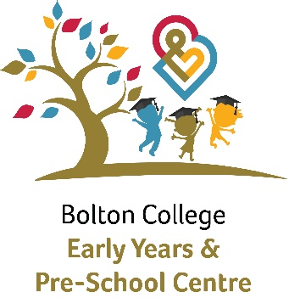­­­

*Curriculum 2024/2025*

*­­­Mission Statement Our nursery is a college-based nursery supported by a board of governors, we are committed to safeguarding and promoting the welfare of our children and expects all staff, volunteers and visitors to share this commitment*

# *A green plant growing on a white background Description automatically generatedThe Early Years and Preschool Centre is committed to providing a warm and caring environment, which provides quality education, and care in a setting where children feel safe, relaxed, valued, happy and secure. Children are valued and respected as individuals and have equal access to all learning opportunities. We will encourage them to live, learn and play in an environment, which reflects and respects their identity, culture and heritage. Each child deserves the best possible start in life and support that enables them to fulfil their potential. We understand that a child’s experiences between birth and age five have the most impact on their future life chances.*

*Curriculum Aim  
This document sets out our curriculum aims which supports and underpins our everyday practice.  
At the Early years and Pre School centre our curriculum is focused and centred around the individual child. We aim to embrace the interests of the children and be responsive to their curiosity and thinking. Our free flow indoor/outdoor approach and workshop style environment allows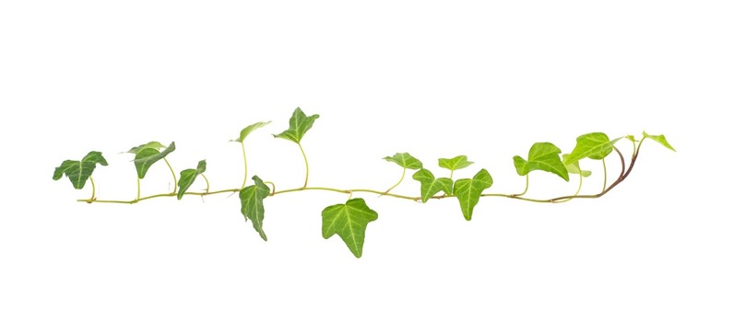 children the freedom to make choices and be an advocate of their own learning.*

* development of our curriculum. Children are given the opportunity to explore, appreciate and understand the natural world, take & manage risks and ultimately develop a love for the outdoors. All children have continuous access to an outside provision.  
Practitioners are facilitators to children’s learning, their role is to observe, support & extend learning, offer meaningful opportunities and experiences whilst listening to the child and tuning in to their needs and interests.*

*Pedagogy  
The curriculum and practice of the Early years and pre-school centre is inspired by a range of different pedagogical approaches.  
Reggio Emilia  
One of the approaches is that of the world-renowned early years educational project from the city of Reggio Emilia in Northern Italy. In Reggio Emilia the image of child is that of competent, strong and amazing individuals who have rights and responsibilities, children are given the opportunities to realise their potential. Children are encouraged to express themselves in a variety of ways, referred to as The Hundred Languages.*

*“For us, each child is unique and the protagonist of his or her own growth. We also note that children desire to acquire knowledge, have much capacity for*

*curiosity and amazement, and yearn to create relationships with others and to communicate”*

*Tiziana Filippini, Reggio Emilia*

*Cultural capital*

*­Our opportunities*

*We ensure children experience new learning and opportunities to gain essential knowledge that they need to prepare them for their future. 'It is the role of the setting to help children experience the awe and wonder of the world*

*We are very grateful to be a part of Bolton College who provide many opportunities and experiences for the children in our care. We offer a variety of enrichment activities where children have the chance to further their experiences and contribute to their learning and development*

*Early Years*

*“Every child deserves the best possible start in life and the support that enables them to fulfil their potential.”* ***EYFS 2021***

*­Our curriculum is underpinned by the 7 areas of learning within the EYFS Statutory Framework. Children are provided with a*

*range of experiences and opportunities that support all areas within the EYFS.*

*Prime Areas*

*Personal, Social and Emotional Development*

*Physical Development*

*Communication and Language*

*Specific Areas*

*Literacy*

*Mathematics*

*Understanding the World*

*Expressive Arts and Design*

*Grow*

*Your physical potential is limitless'*

* *Knowledge of own body and what shapes a healthy lifestyle*
* *Enjoying being physically active*
* *Using a variety of tools to develop muscle growth'*

*You have a voice'*

* *To confidently communicate needs, interests, thoughts and ideas*
* *Be an active contributor within my classroom*
* *Show an appreciation for the voice of others*

*'Have a strong sense of self and well-being'*

* *Be a kind and caring member of the community - Be able to recognise and manage a range of emotions*
* *Being responsible and independent with my own   
  self-care.*

*Explore*

*'Embrace a love of the outdoors'*

* *Understanding growth, change and the effects on the environment*
* *Be able to follow and understand the outdoor world boundaries*
* *Being able to initiate and lead their own learning with open ended resources*

*­‘'Being an advocate for your own learning'*

* *Taking and managing risks*
* *Take on challenges, new experiences and be proud of accomplishments*
* *Be a reflective learning*

*'An appreciation of your senses'*

* *To use our senses to widen opportunities and curiosity about the world around us*
* *Be open to experience a variety of textures, materials, sounds, tastes and smells*
* *Understand how to use our senses to support self-regulation*

# *Discover*

*Develop a love of literature'*

* *Enjoy listening to, reading and retelling favourite stories, songs and rhymes*
* *An open book with a door coming out of it

  Description automatically generatedEmbrace and explore real life experiences*
* *Express ourselves through a range of media*

*'Experience your creative potential'*

* *Use a variety of resources to create and explore*
* *Engage independently on imaginative play in a range of contexts*
* *environments*

*'Begin to understand you are part of a wider world'*

* *Join in with and embrace other cultures and beliefs*
* *Know what is important to us, our family and what makes us unique - How I can make a difference in the world*

*This Curriculum has been written by Audrey West*

*Audrey.west@boltoncc.ac.uk*